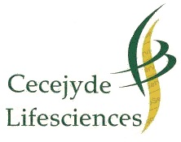
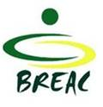

DNA MASTER CLASS APPLICATION FORM

Workshop Dates: Please tick your preferred stream
STREAM 1: 20 – 22 June, 2018 [ ]
STREAM 2: 27 – 29 June, 2018 [ ]

A- Applicant’s Details
Surname: |  | First name:
Sex : Male □ Female □ | Country:
Physical Address:

Telephone: | Email (mandatory): |  | Fax:
Passport Number: | Passport Expiry Date:
B- Current work position/role of applicant
Current position title:

Name of employer (if self-employed, please state):

Address of institution/organisation/work place:

Telephone : | Email: |  | Fax :
C- Areas of interest
Tick all areas of research interest
Polymerase Chain Reaction (PCR) [ ]
DNA extraction and profiling [ ]
Detection of genetically modified plants/food [ ]
RNA Extraction and gene expression profiling [ ]
Molecular diagnostics [ ]
DNA Barcoding [ ]
Phylogenetic analysis [ ]
Bioinformatics [ ]
Drug discovery [ ]
Others [ ]. Please specify………………………………………..

D- Motivation and Experience
Briefly describe your current responsibilities/role/research (200 words)

Briefly describe your expectations and how this workshop will benefit your career/research (200 words)

Rate your experience in molecular biology on a scale of 1 to 10 (with 1 = No prior experience and 10 = Expert user of molecular biology techniques)………………………………………………………………………
Signature/Date:

This form should be submitted together with a short CV at the latest by June 15, 2018 via electronic emails to admin@breacnigeria.org Details of course fees and other guidelines are available via www. http://www.breacnigeria.org/dna-master-class. For further details contact: admin@breacnigeria.org

